2018 Summer Workshop & Tour
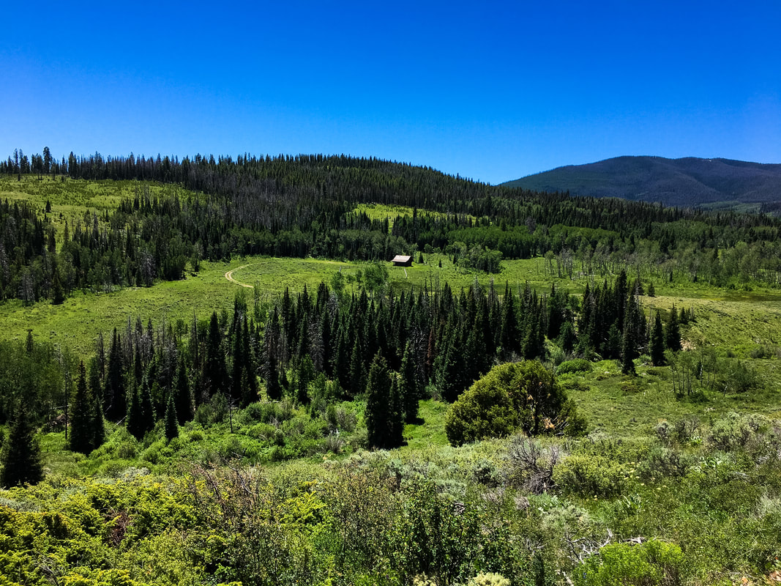

Each summer we offer a workshop and tour open to members and non-members alike. For the summer 2018 tour and workshop June 20 -21, we will be at Jordan Angus Ranch, our Excellence in Conservation Award winner's ranch, near Briggsdale, Colorado on day one. On our second day, we will have the opportunity to visit several locations in Northern Colorado and see the different ways water is used in Weld County, how to manage “Buy & Dry” property, as well as the storage and process of distribution of water in this area.

